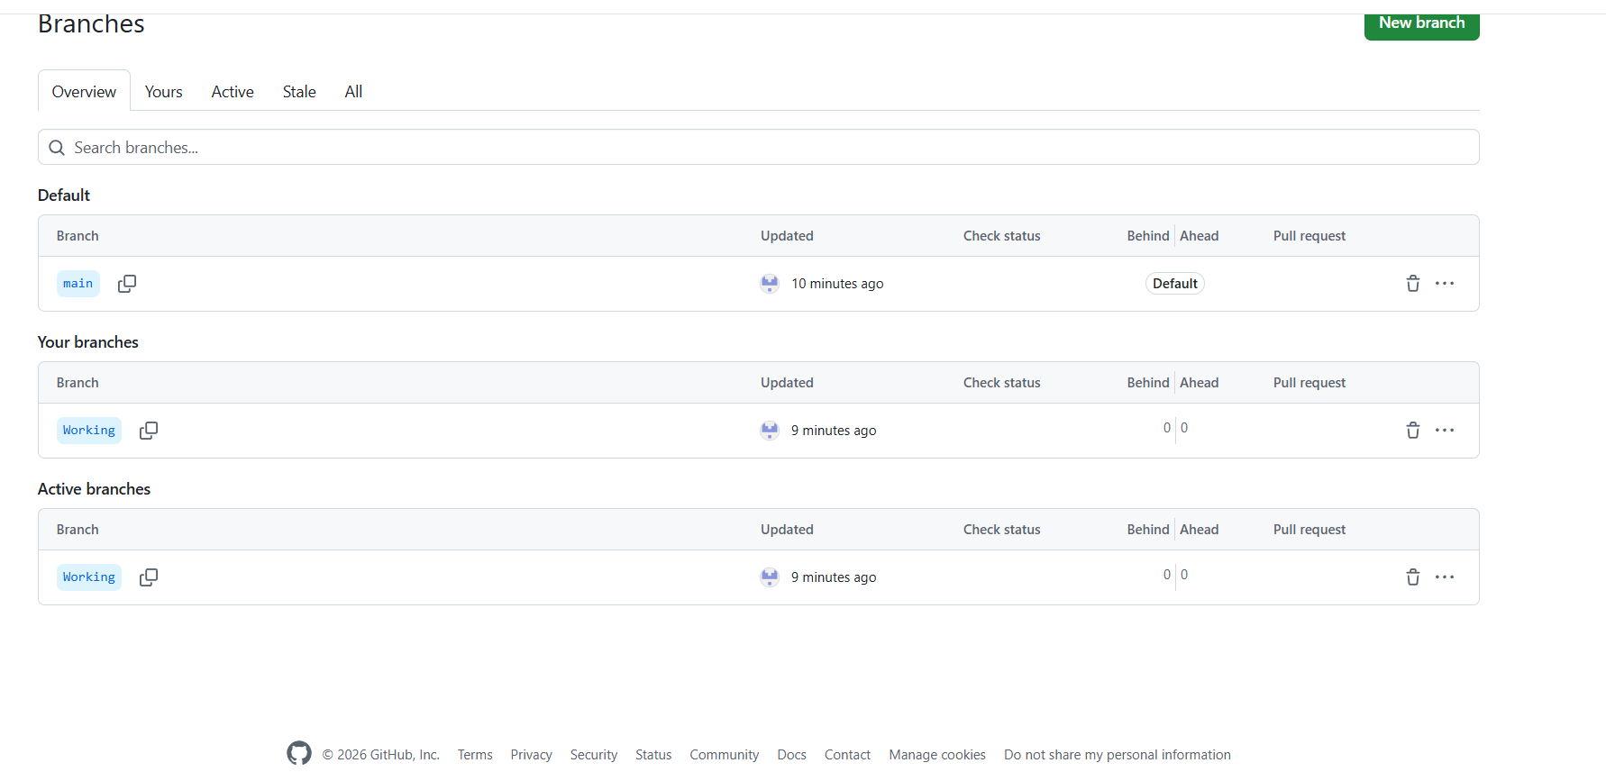
A1 : Creation of the Working branch in the remote GitHub repository.
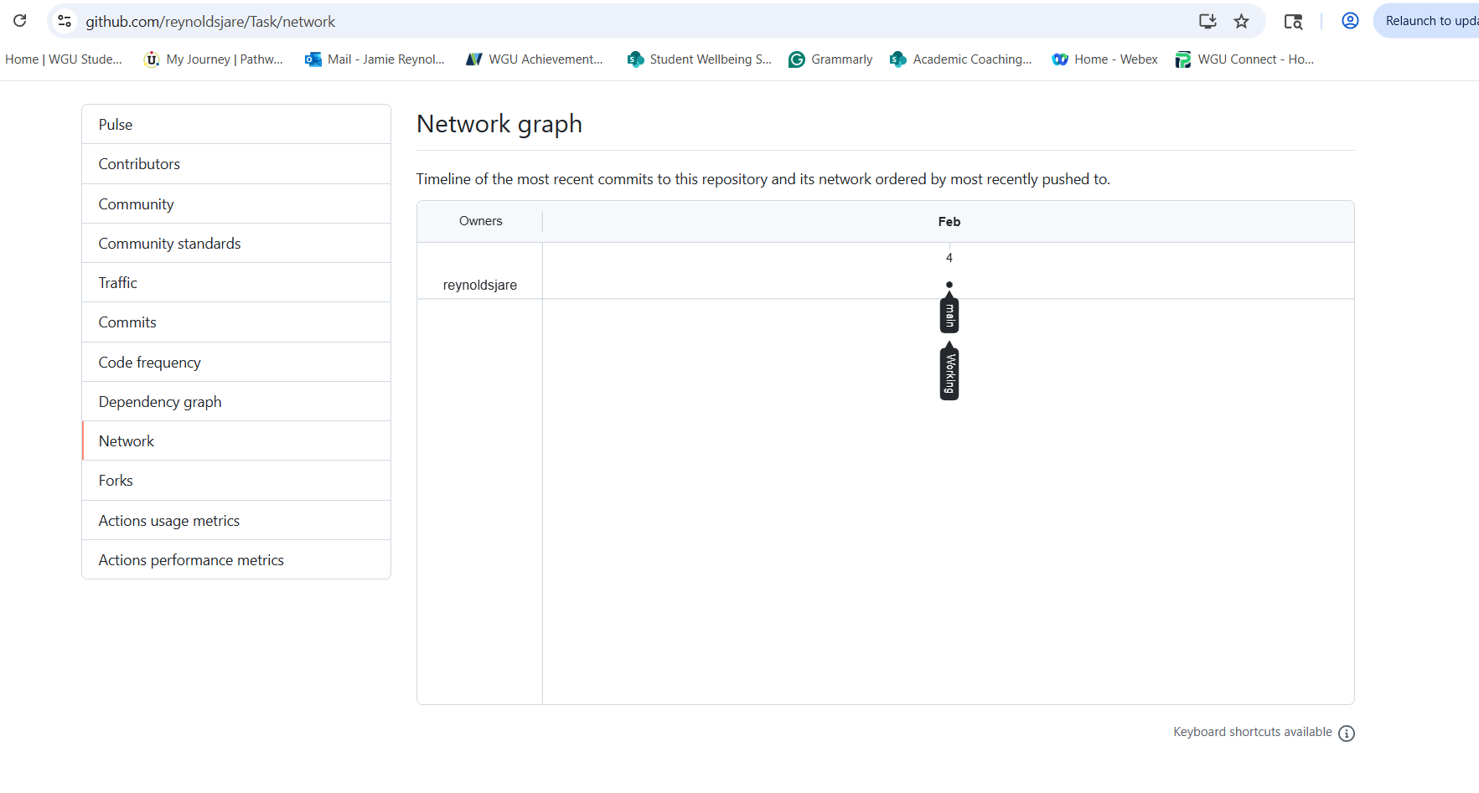
A2: Repository graph showing the relationship between the main and Working branches.

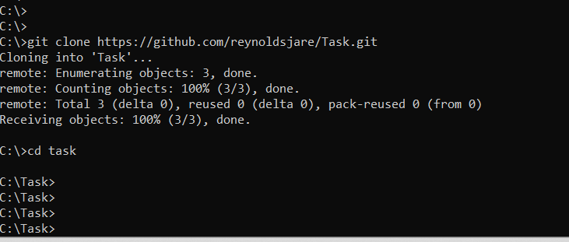
B: Cloning of the remote GitHub repository to the local machine using the command line interface.
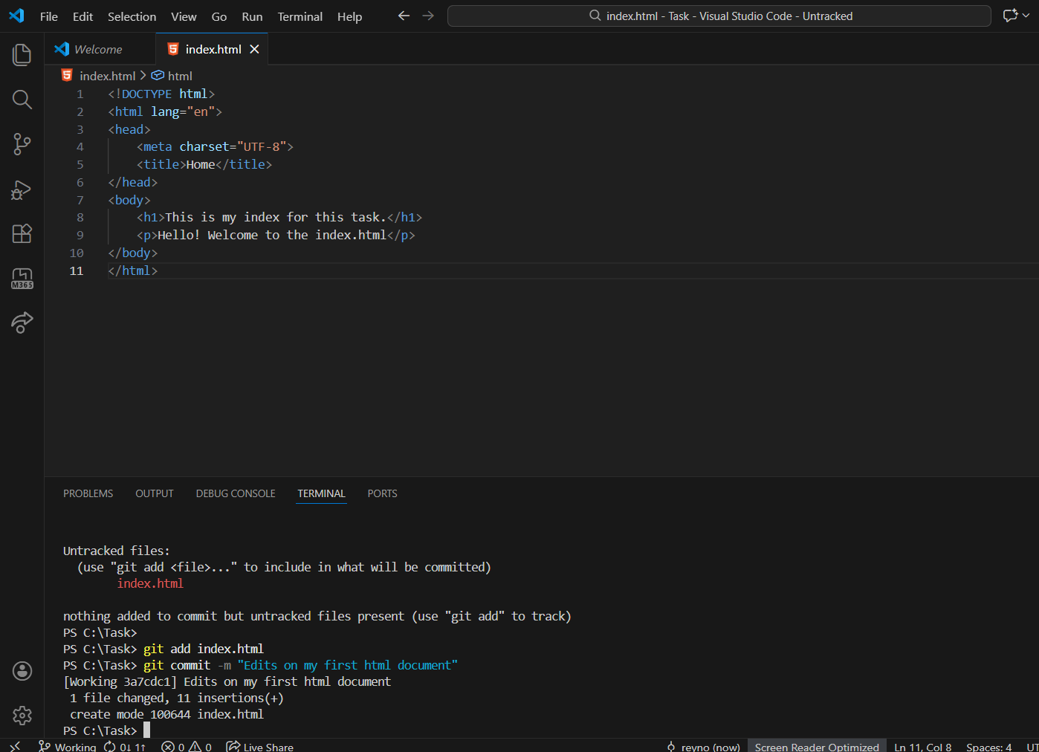
C1: Commit of the first HTML file (index.html) to the Working branch with a descriptive commit message.
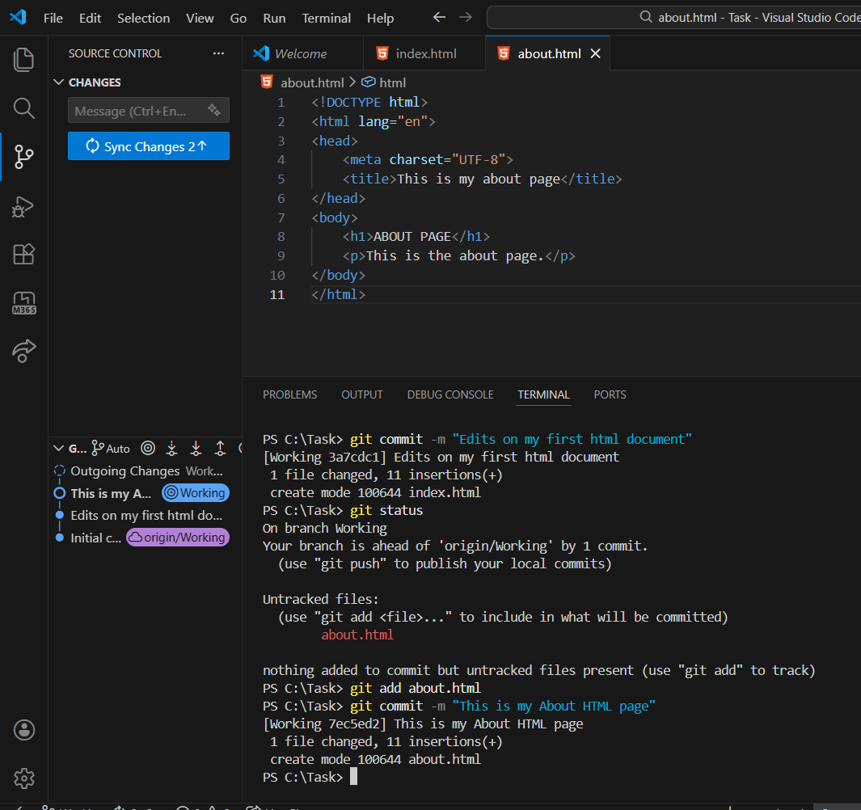
C2: Commit of the second HTML file (about.html) to the Working branch with a descriptive commit message.
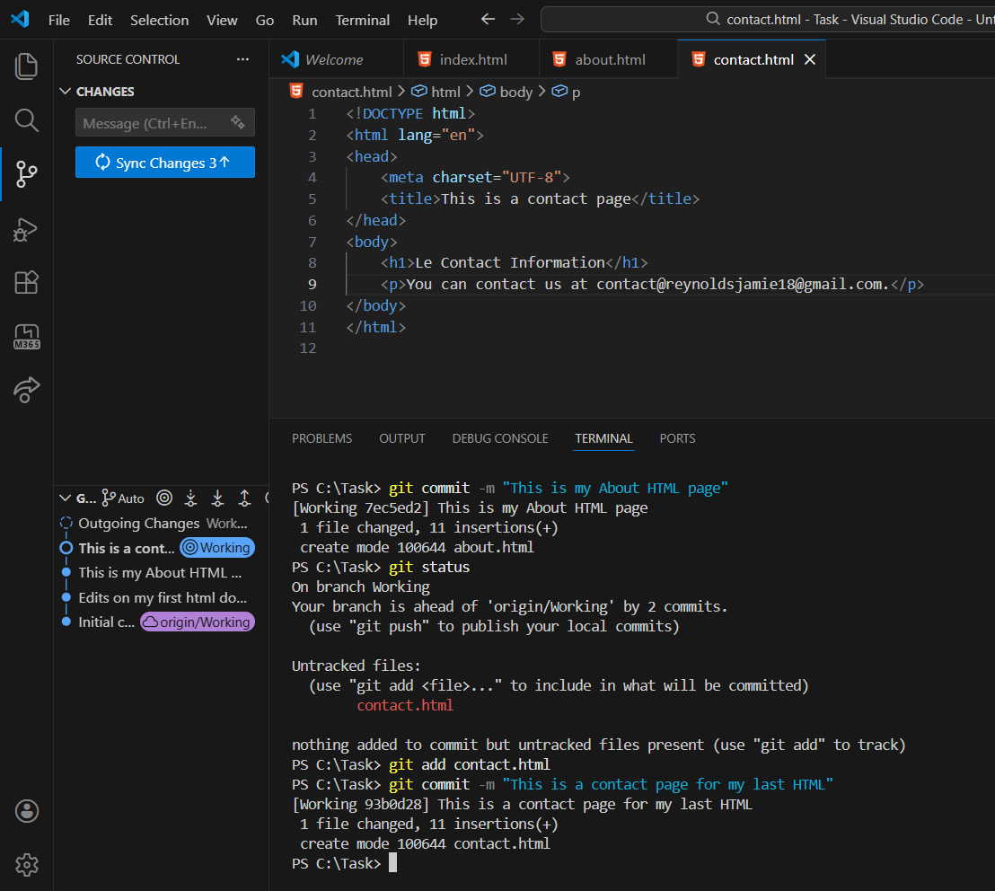
C3: Commit of the third HTML file (contact.html) to the Working branch with a descriptive commit message.
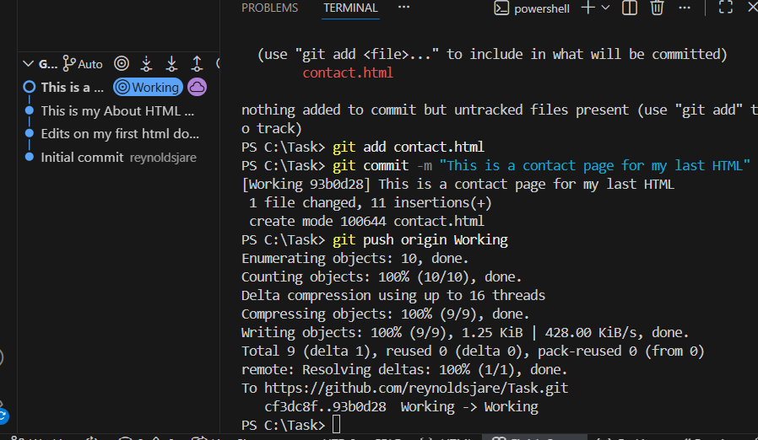
C4: Push of the Working branch to the remote GitHub repository.
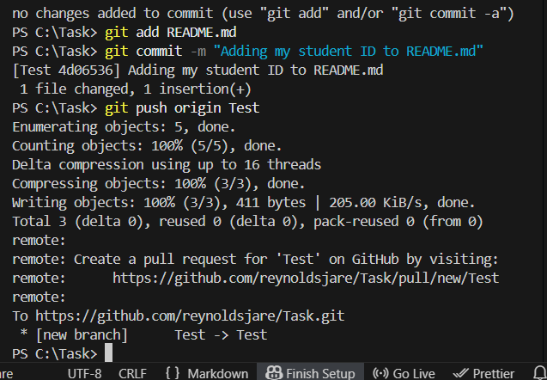
D: Creation of the Test branch and commit adding the student ID to the README file.
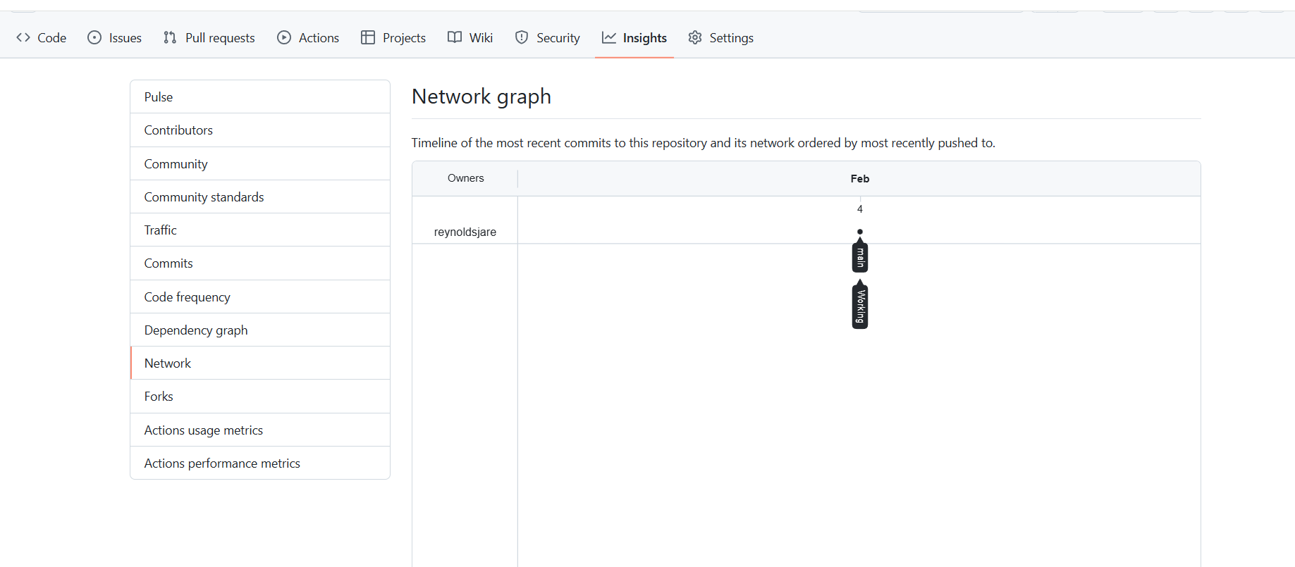
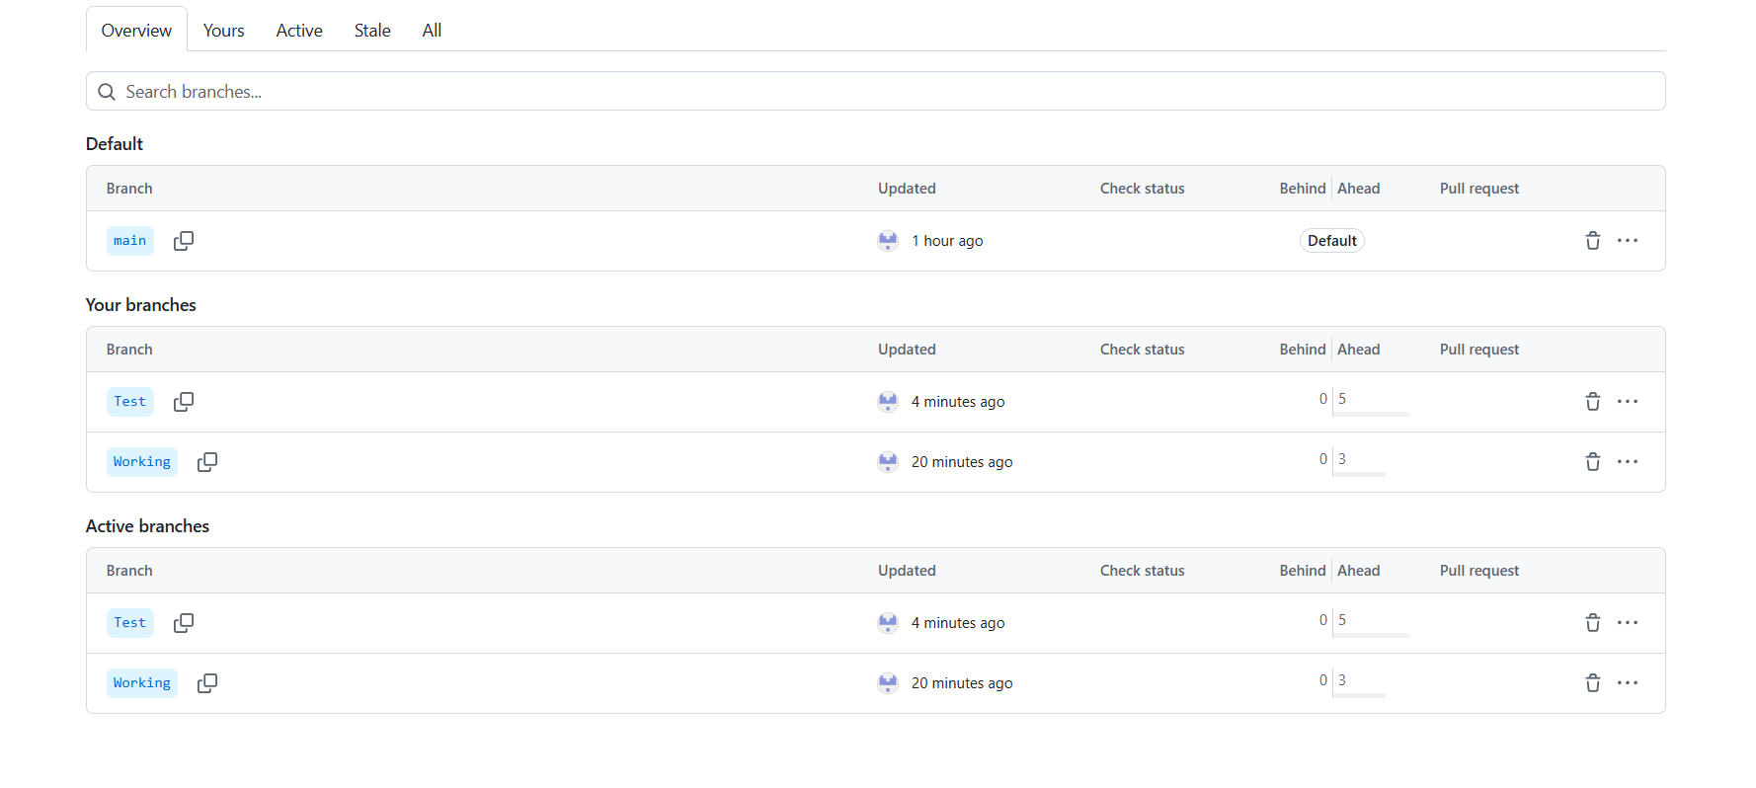D1: GitHub repository graph and branch listing showing the Test branch pushed to the remote repository.
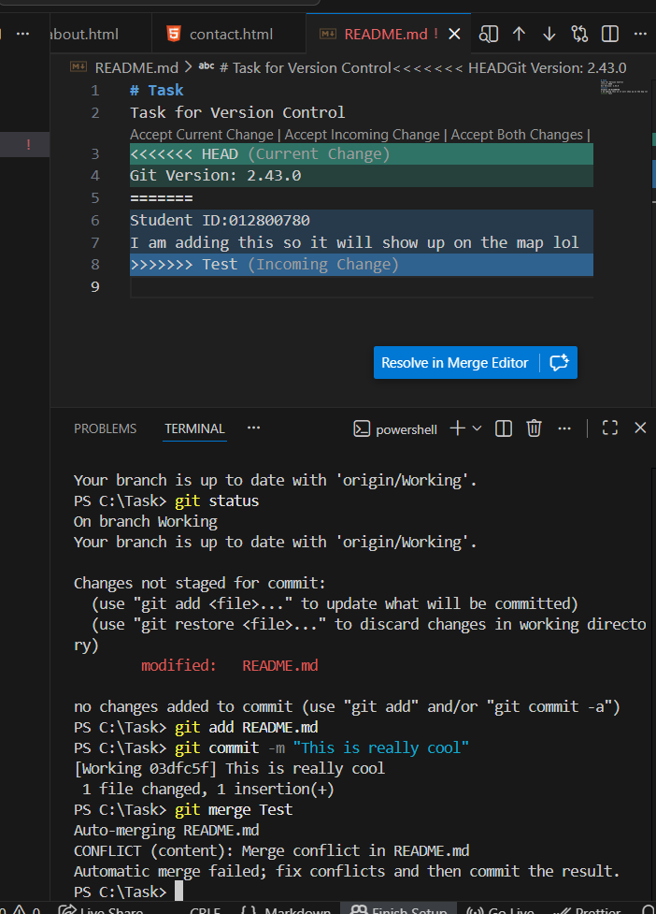
E: Merge attempt of the Test branch into the Working branch resulting in a merge conflict.

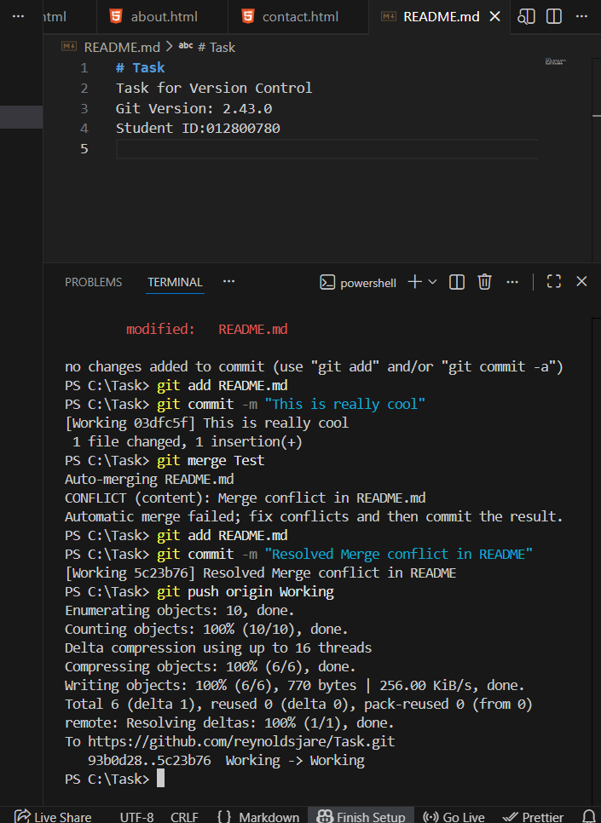
E1: Resolution of the merge conflict in the README file followed by committing and pushing the changes to the Working branch.
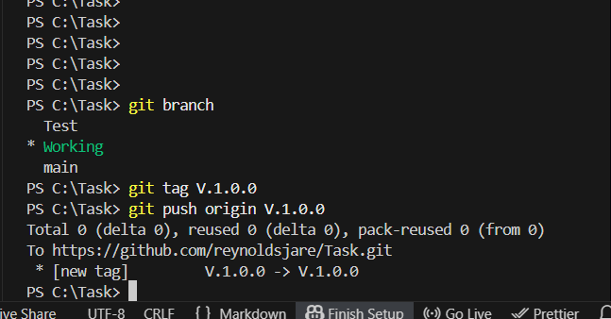
F: Tagging the Working branch as version V.1.0.0 and pushing the tag to the remote repository.
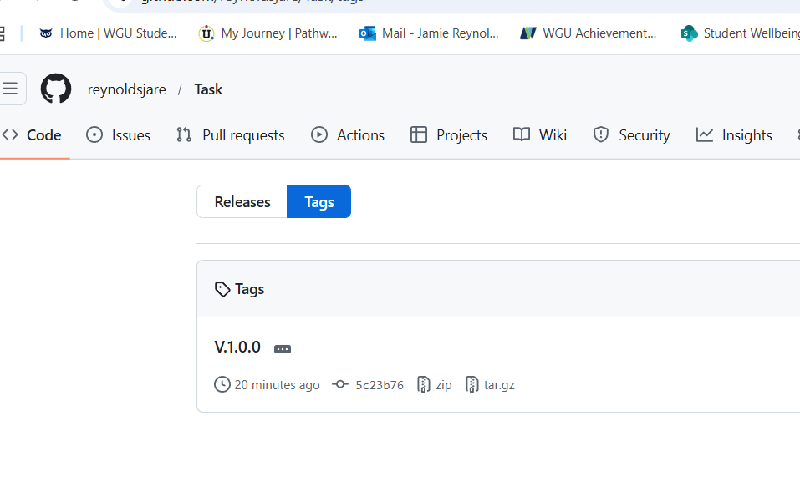
F1: Remote repository view showing the V.1.0.0 tag associated with the Working branch.

